1)
Position: Risk and Control Function Opportunities
Location: NY - New York
Job Code: 11-RC1
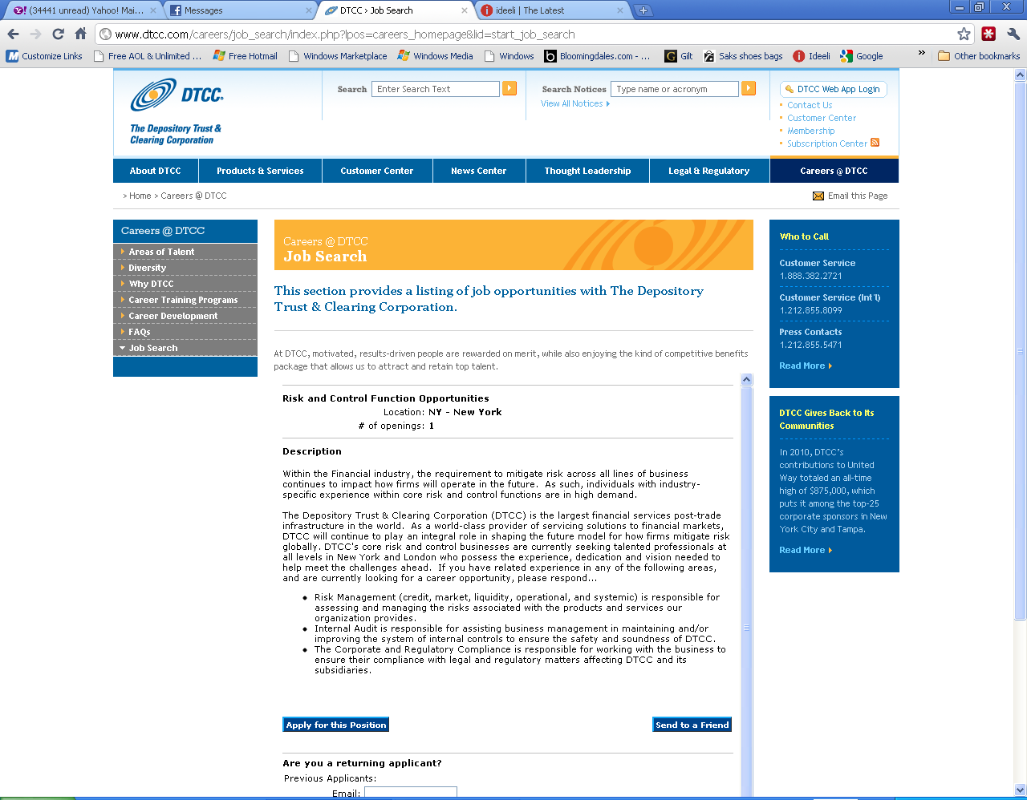

2)
<< Back
Position: Senior Risk & Control Advisor (RC)
Location: NY - New York
Job Code: 11-0244

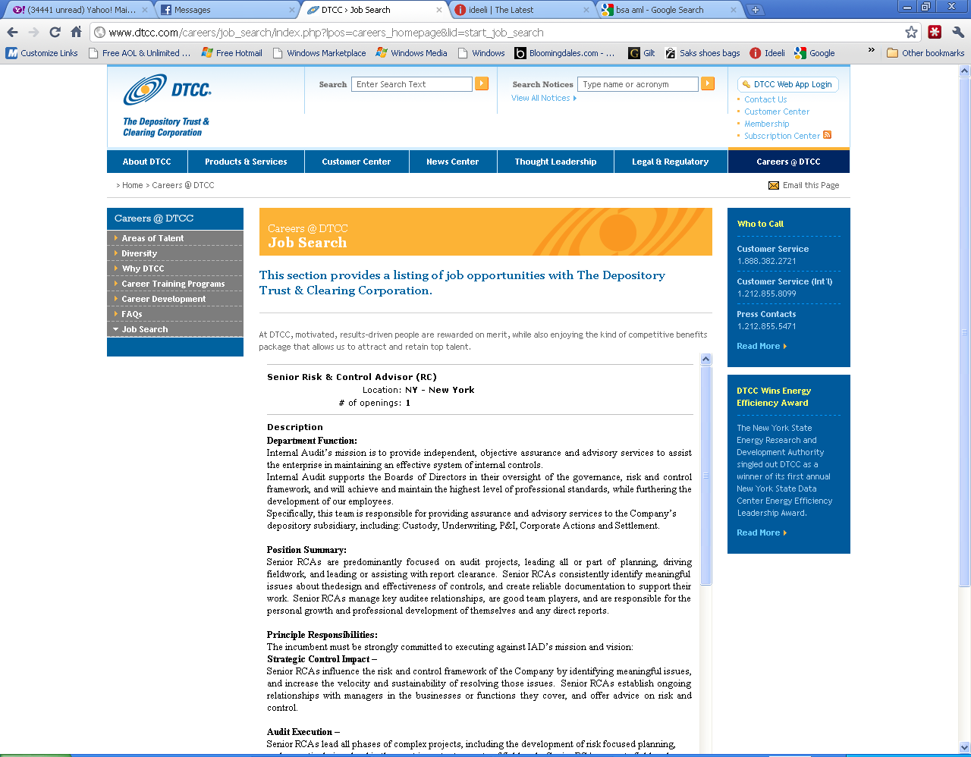
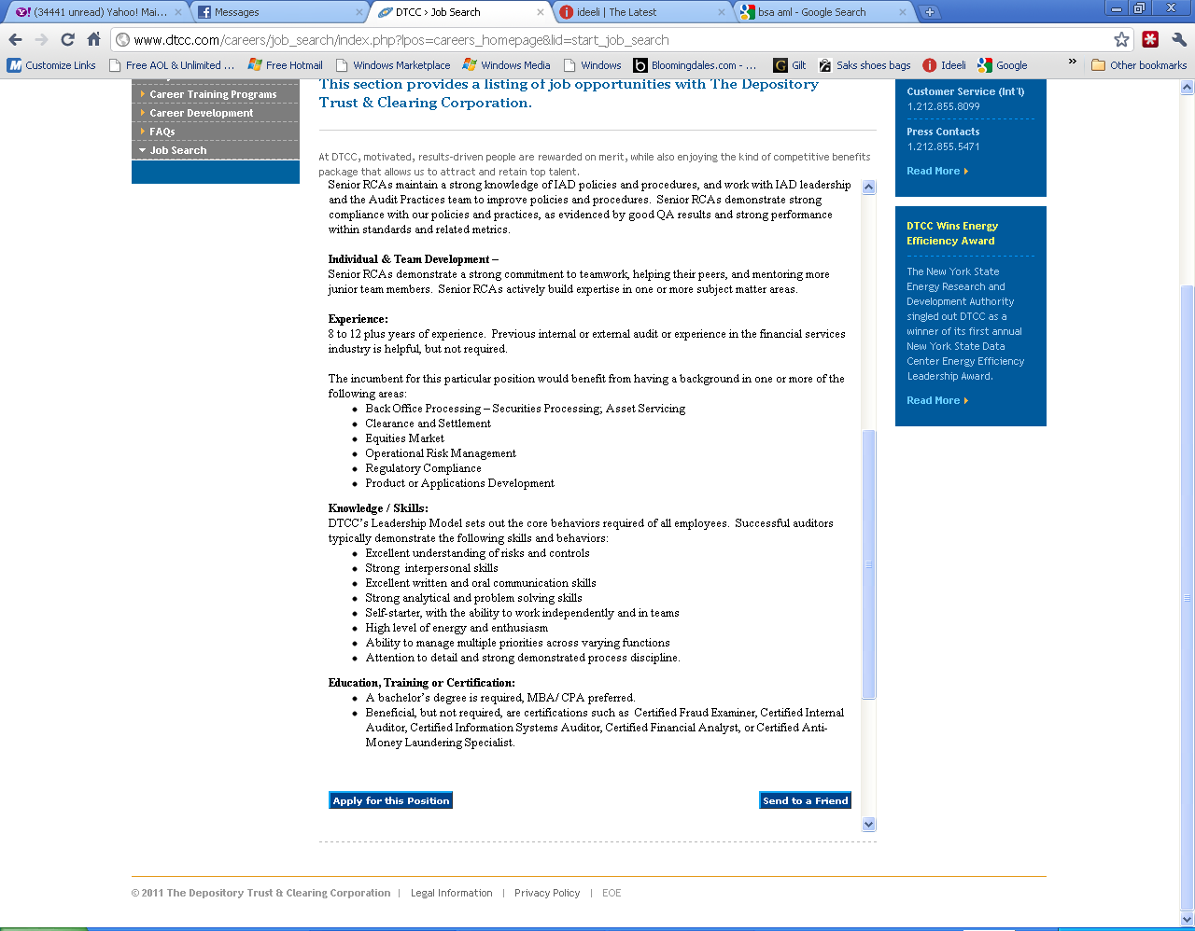

3)
<< Back
Position: Audit Practices Quality Controller
Location: NY - New York
Job Code: 11-0236
